**[CCN]**

**Lab No 10 Tasks**

**Name: Javeria Zaheer**

**Sap Id: 41473**

**Task 1:**

**Perform all the tasks in the manual and take screenshot. (10 marks)**

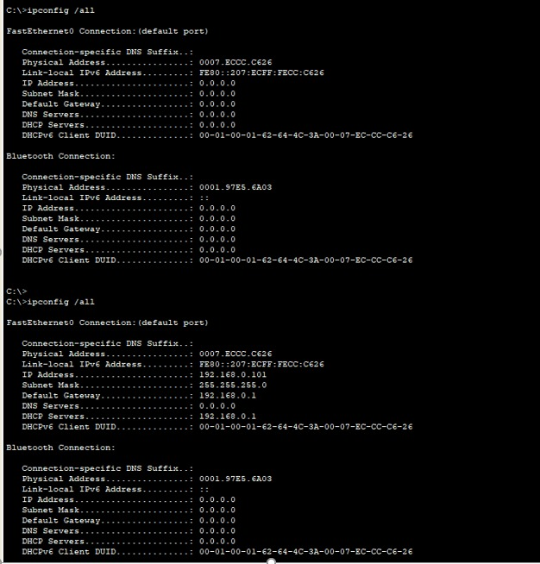

**ipconfig /all**

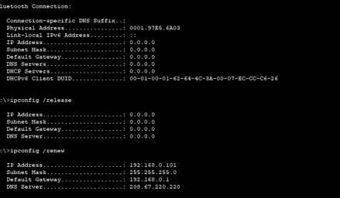

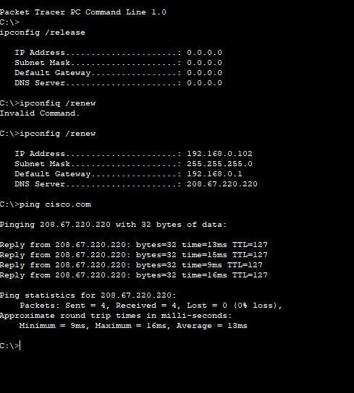

**Laptop**

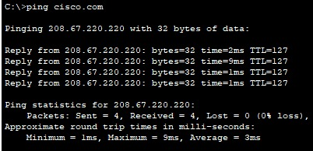

**Pc**

**Cloud**

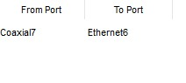

**Router**

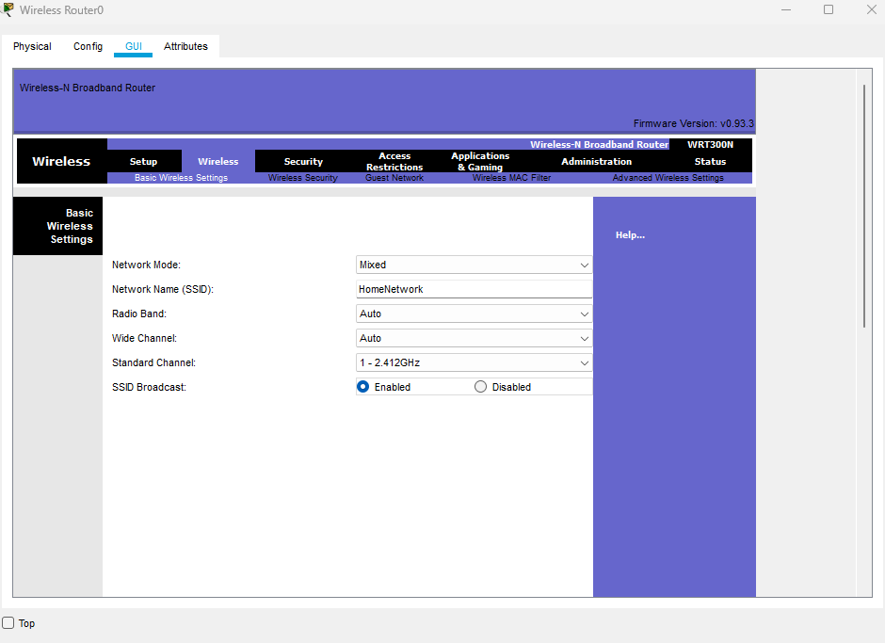

**Diagram:**

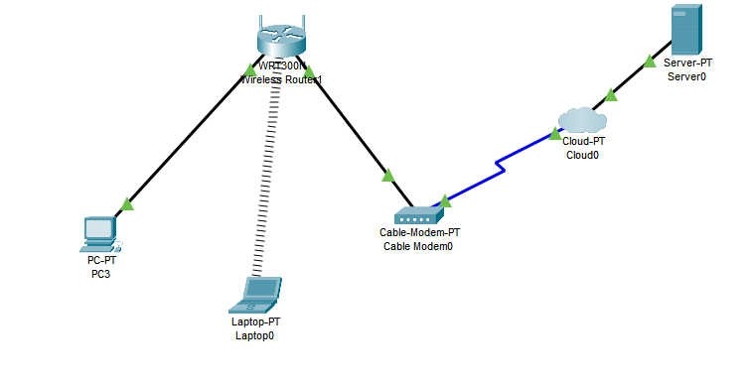

**Task 2:**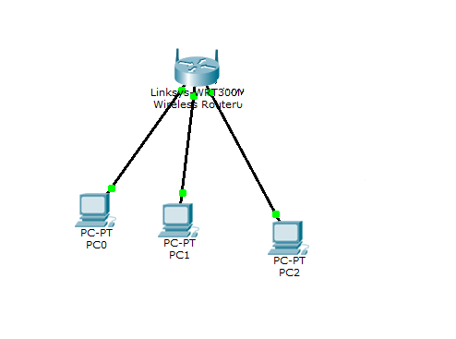

**Create the above topology. (10 marks)**

